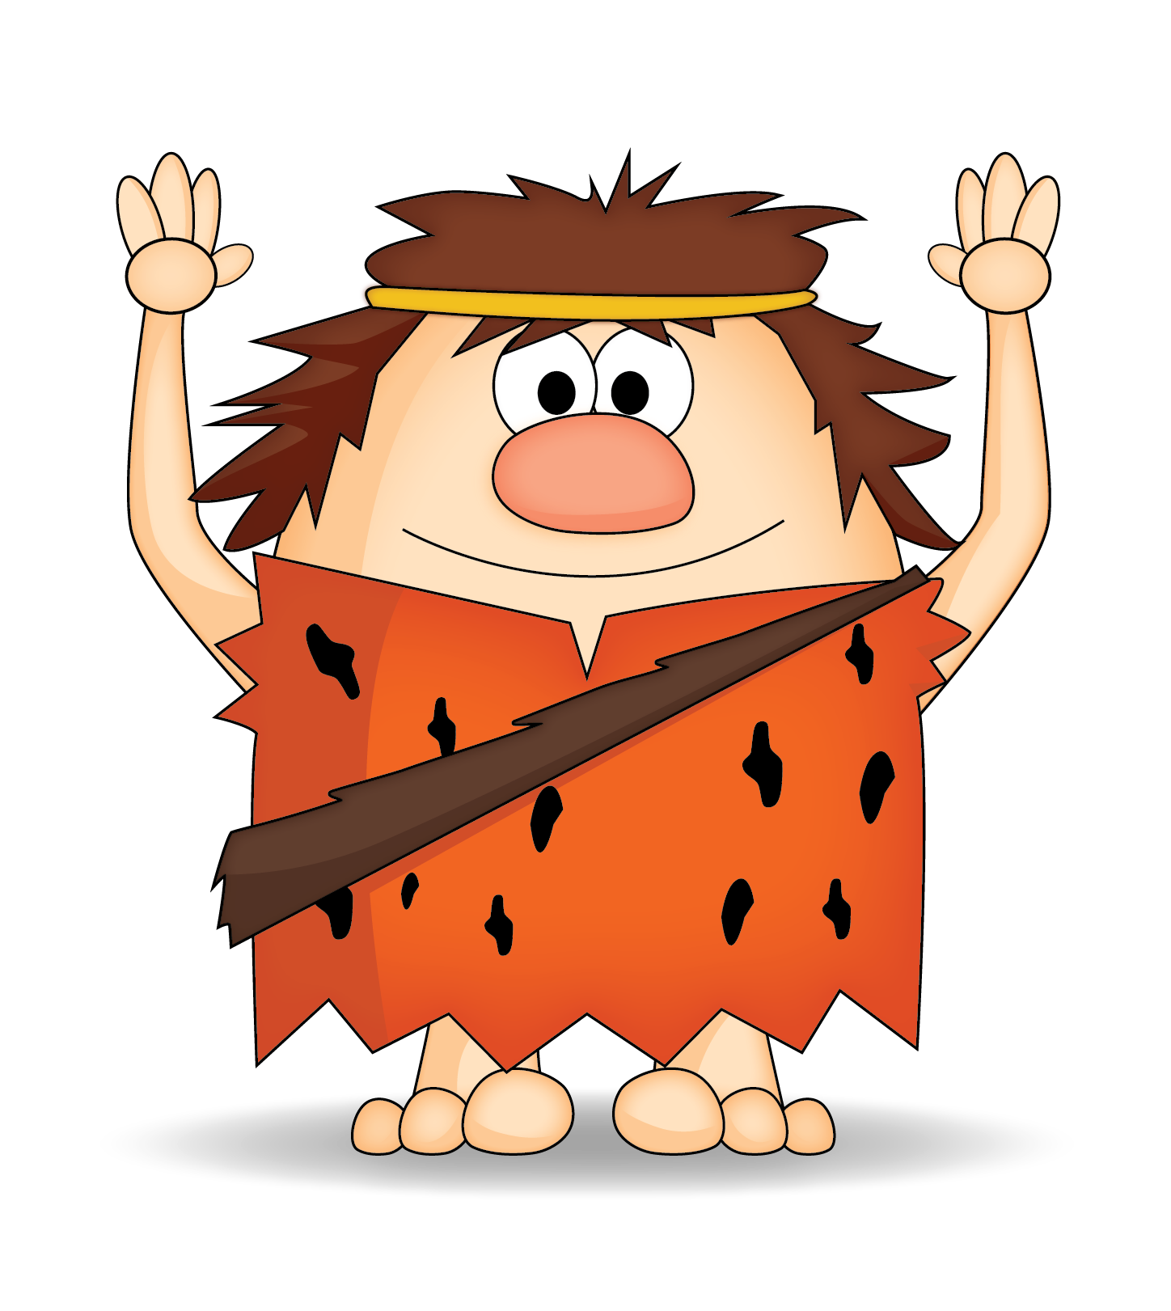
PLEASE BE MY SPECIAL GUEST
PLEASE BE MY SPECIAL GUEST

You’re invited to a

fAMILY nIGHT aDVENTURES!
[Event Date]
[Event Time]
Our Home!
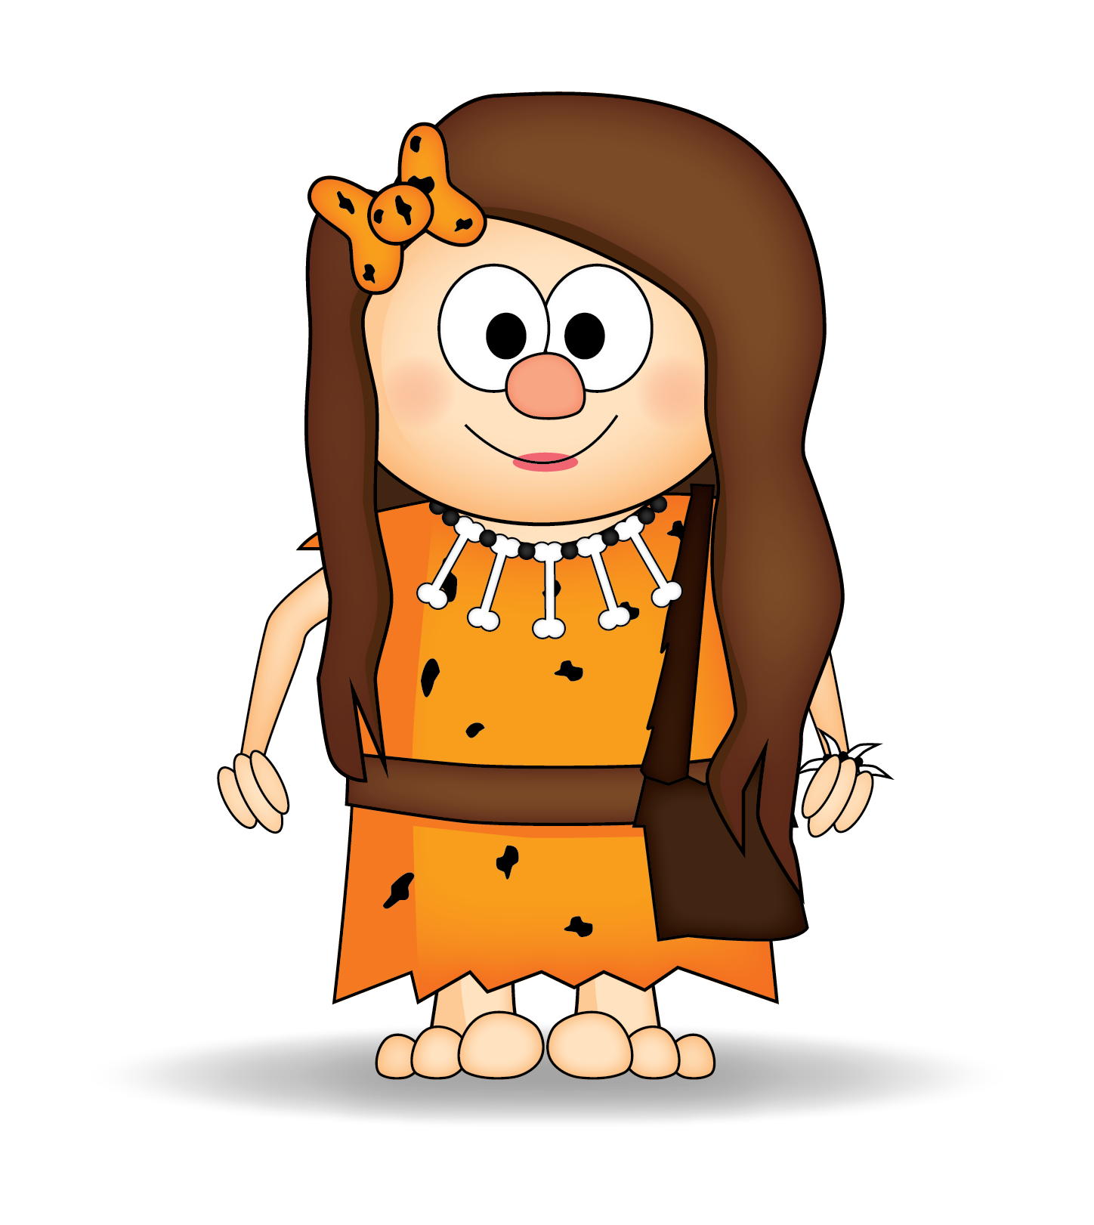
Love Mom!

You’re invited to a

fAMILY nIGHT aDVENTURES!
[Event Date]
[Event Time]
Our Home!
Love Mom!

